ANALYTICAL FINDINGS
E-commerce Delivery & Logistics Performance Analysis

1. Executive Summary
The cleaned dataset contains 180,519 order-item rows representing 65,752 distinct orders across 23 regions. Delivery performance was evaluated using 62,897 eligible orders with a delivery status of Advance shipping, Shipping on time, or Late delivery. Of these, 26,849 orders (42.69%) were early/on time and 36,048 (57.31%) were late. The cancellation rate, using Order Status = CANCELED, was 1,367/65,752 (2.08%).
The central finding is that late deliveries exceed on-time/early deliveries. The results point to a broad delivery reliability issue rather than a problem confined to one region. Regional and shipping-mode comparisons can help prioritize investigation, but they do not establish the operational cause of delays.

2. Dataset and EDA Findings
- Source: DataCo_Cleaned_Interim.csv (180,519 rows and 53 columns).
- Unit of analysis: distinct Order Id. The source has approximately 2.75 item rows per order on average; counting rows would inflate order volumes.
- Geographic coverage: 23 order regions.
- Delivery status groups: 62,897 eligible delivery orders; 2,855 records/orders have a non-eligible delivery status.
- Order date range in the validated KPI documentation: 2015-01-01 to 2018-01-31.

3. Key KPI Results
KPI | Numerator / value | Denominator | Result
Total unique orders | 65,752 | — | 65,752
Eligible delivery orders | 62,897 | — | 62,897
On-time / early delivery | 26,849 | 62,897 | 42.69%
Late delivery | 36,048 | 62,897 | 57.31%
Cancelled orders (Order Status = CANCELED) | 1,367 | 65,752 | 2.08%
Average actual shipping days | 3.50 days | Valid eligible order records | 3.50 days
Average scheduled shipping days | 2.94 days | Valid eligible order records | 2.94 days

Definitions: On-time/early includes Advance shipping and Shipping on time. Late includes Late delivery. The delivery-rate denominator excludes Shipping canceled. Cancellation is separately defined by Order Status = CANCELED, so it is not interchangeable with the Shipping canceled delivery-status group.

4. Delivery Delay Analysis
Late orders account for 57.31% of eligible deliveries, compared with 42.69% early/on-time. The difference is 14.63 percentage points. The validated duration fields average 3.50 actual shipping days versus 2.94 scheduled days, a difference of 0.57 days.
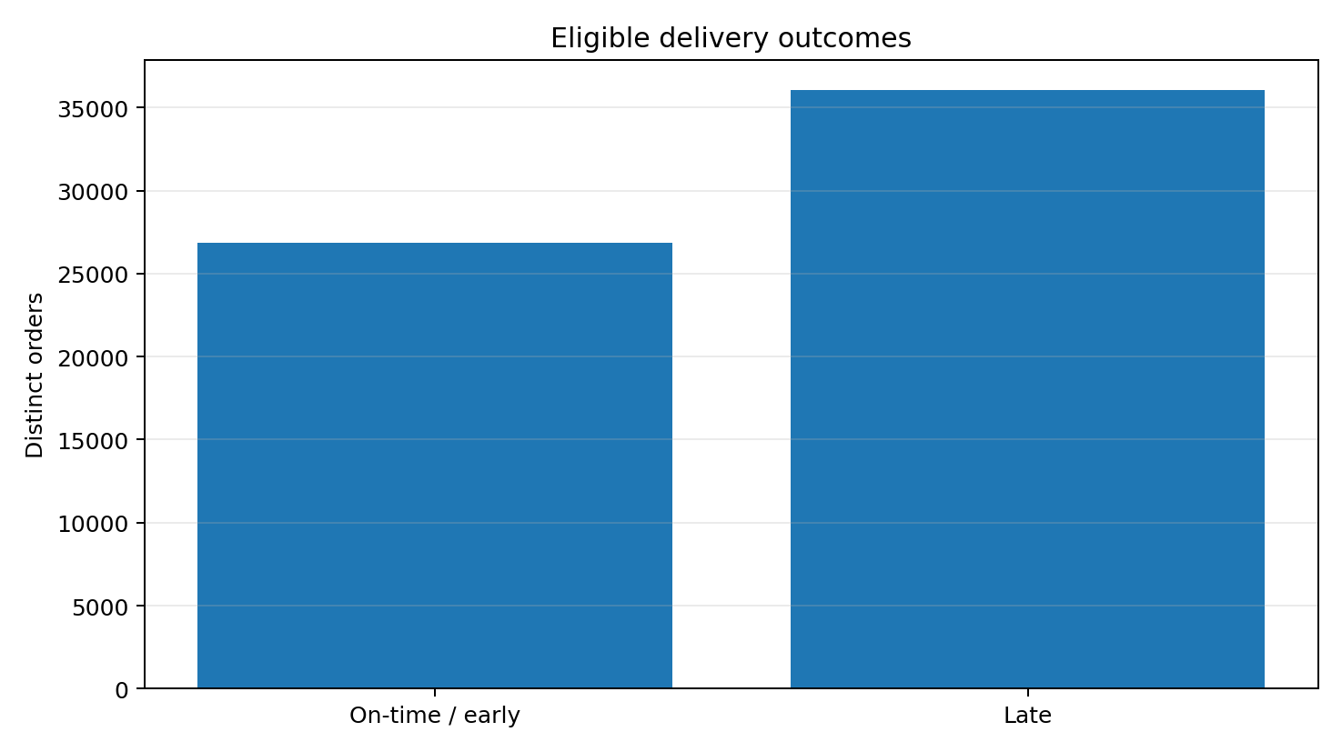
Figure 1. Eligible delivery outcomes based on distinct order counts

5. Regional Delivery Performance
Central Africa has the lowest observed on-time/early rate at 39.96% (213 of 533 eligible orders). Other low-performing regions include East Africa (40.92%), South of USA (41.17%), West Asia (41.50%), and Western Europe (41.60%).
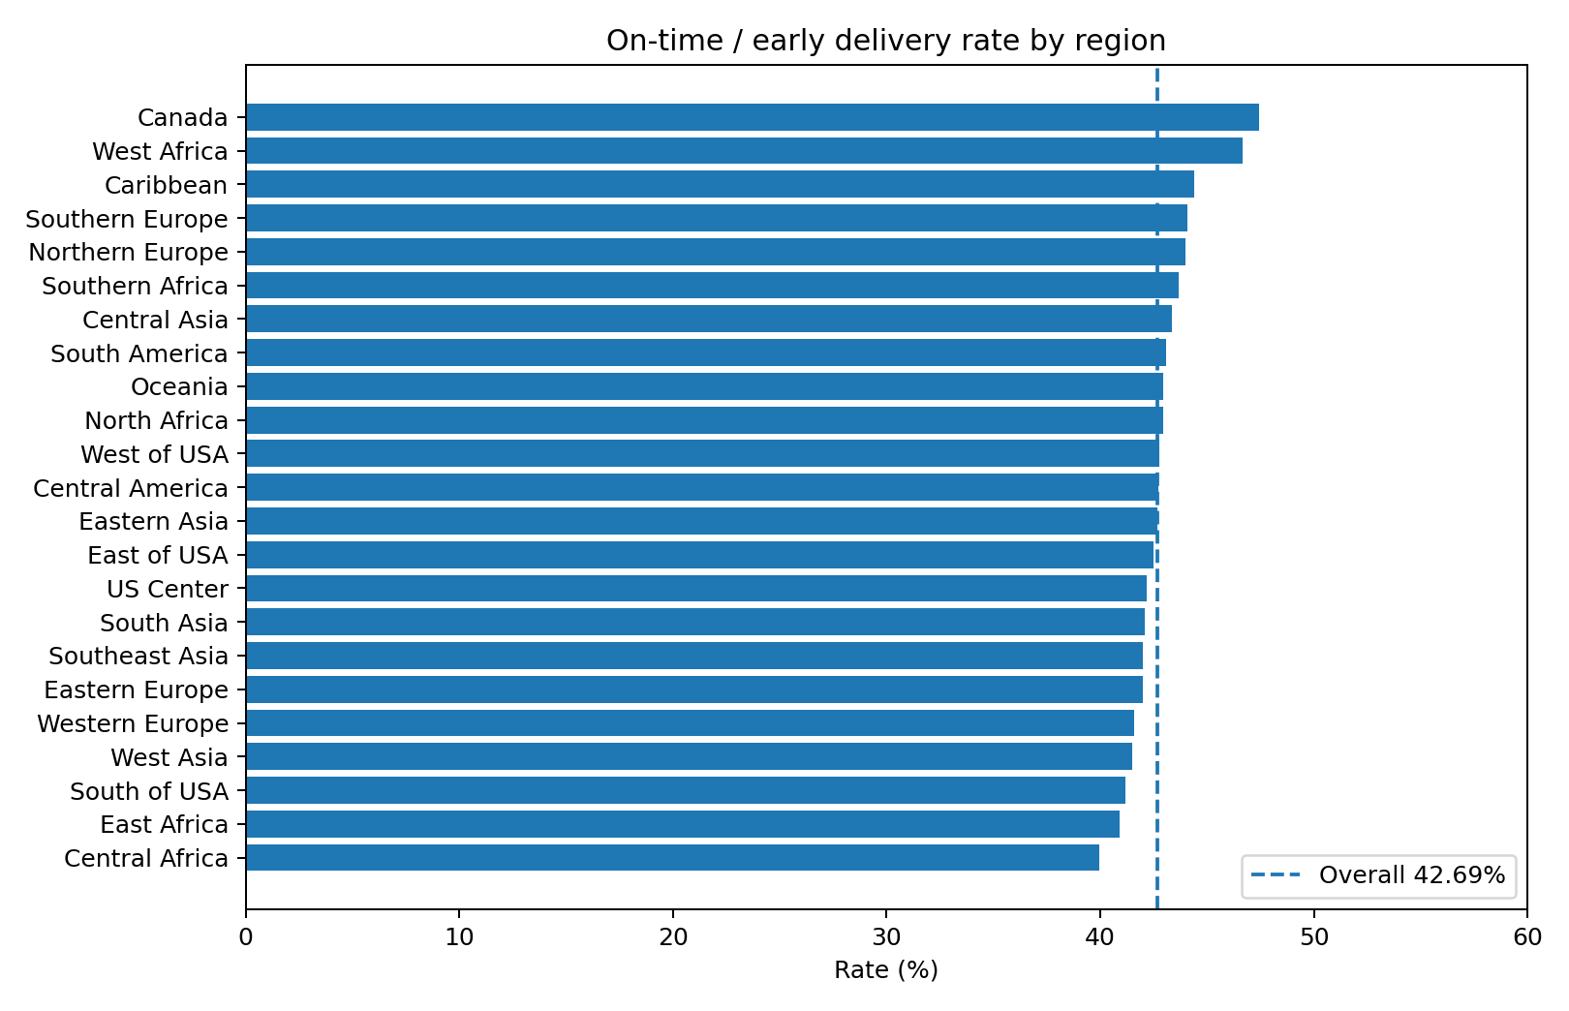
Figure 2. Regional on-time/early rates; dashed line marks the overall rate
Largest late-order counts:
- Western Europe: 5,585 late orders out of 9,563 eligible (58.40% late).
- Central America: 5,156 late orders out of 9,001 eligible (57.28% late).
- South America: 2,696 late orders out of 4,738 eligible (56.90% late).
- Southeast Asia: 2,421 late orders out of 4,173 eligible (58.02% late).
- Oceania: 2,382 late orders out of 4,175 eligible (57.05% late).
Interpretation: rate-based prioritization identifies weak performance relative to each region's eligible volume, while count-based prioritization identifies where the largest number of late orders occurs. Both should be considered together.

6. Shipping-Mode Performance
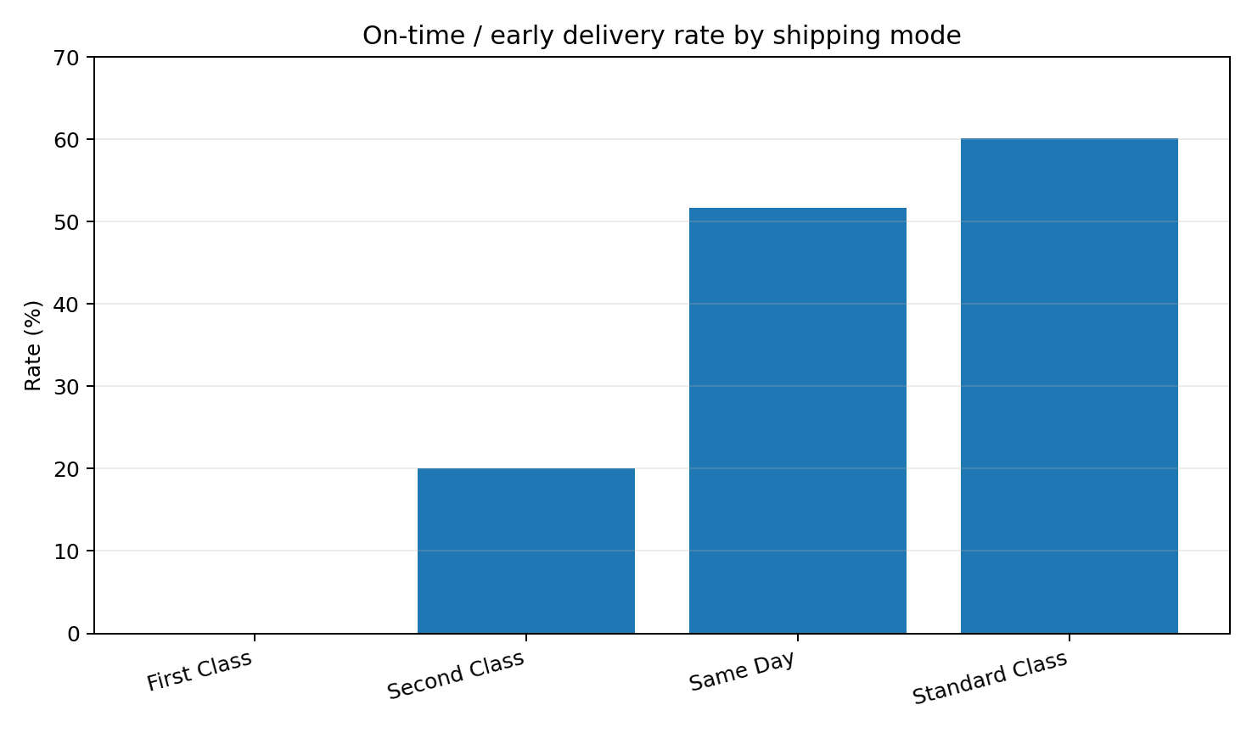
Figure 3. On-time/early rate by shipping mode

Shipping mode | Eligible orders | On-time / early | Late | On-time rate
Standard Class | 37,632 | 22,637 | 14,995 | 60.15%
Same Day | 3,407 | 1,759 | 1,648 | 51.63%
Second Class | 12,256 | 2,453 | 9,803 | 20.01%
First Class | 9,602 | 0 | 9,602 | 0.00%

Standard Class has the highest observed on-time/early rate (60.15%) and the largest eligible volume (37,632). First Class shows 0 on-time/early orders in this extract (0.00% rate), which is an unusual result and should be validated against the source status coding and service-level definitions before drawing conclusions about the carrier or service.

7. Monthly and Trend Findings
The supplied regional monthly trend workbook classifies 9 regions as improving and 14 as worsening based on the first-to-last observed monthly delay-rate comparison. This is a directional summary; monthly volumes vary and a change between two endpoints does not prove a sustained trend.

8. Major Operational Issues and Follow-up
- Late delivery is the dominant eligible outcome (57.31%), so the overall priority is to investigate delay drivers across the fulfilment and transport process.
- Central Africa and East Africa have comparatively low on-time/early rates; review dispatch cut-off adherence, warehouse release timing, carrier hand-off scans, route exceptions and local operating constraints.
- Western Europe, Central America and South America have the largest late-order counts; investigate these high-volume regions because improvements may affect many orders.
- Shipping-mode results differ substantially. Validate the First Class status pattern and compare like-for-like orders before treating mode differences as causal.
- Use order-level timestamps, carrier scans, warehouse processing records and exception codes to separate processing delay from transit delay.

9. Analytical Limitations
- The CSV is item-level, with multiple rows per order. All order KPIs in this report use distinct Order Id and one order-level record to avoid double counting.
- The supplied dataset has shipping-duration fields but no separate confirmed customer-delivery timestamp suitable for independently calculating dispatch-to-delivery transit time. Average actual shipping days should not be described as confirmed customer delivery duration without validating its field definition.
- Delivery status is used as the classification proxy for early/on-time/late. Operational timestamp evidence is needed to independently verify those labels.
- The cancellation KPI uses Order Status = CANCELED (1,367 orders). Delivery Status = Shipping canceled is a broader group (2,855 in the validated documentation) and also includes suspected-fraud orders; the two definitions must not be mixed.
- Regional and shipping-mode comparisons are descriptive. They do not prove that region, carrier, or shipping mode caused a delay.
- Some subgroup results, especially unusual patterns such as First Class having no on-time/early orders, require validation before operational decisions.
- A duplicate copy of the regional recommendations workbook was supplied; the duplicate was treated as one source, not independent corroboration.

10. Conclusion
The analysis of 65,752 distinct orders shows that 57.31% of eligible deliveries were late, while 42.69% were early/on time. The cancellation rate under the agreed Order Status definition was 2.08%. Regional and shipping-mode comparisons provide useful investigation priorities, but operational causes should only be assigned after checking dispatch, carrier and delivery event data. The strongest next step is to validate status anomalies and obtain reliable timestamp-level records to separate warehouse processing delays from transport delays.

